**Problem assignment 6**

*Due: Wednesday, October 16, 2019*

**Problem 1**

**Part a.**

(i). It is syntactically invalid and therefore meaningless.

(ii). It correctly expresses the English sentence.

(iii). It is syntactically valid but does not express the meaning of the English sentence.

**Part b.**

(i). It correctly expresses the English sentence.

(ii). It is syntactically valid but does not express the meaning of the English sentence.

(iii). It is syntactically invalid and therefore meaningless.

(iv). It is syntactically invalid and therefore meaningless.

**Part c.**

(i). It correctly expresses the English sentence.

(ii). It correctly expresses the English sentence.

(iii). It is syntactically valid but does not express the meaning of the English sentence.

(iv) It is syntactically valid but does not express the meaning of the English sentence.

**Part d.**

(i). It correctly expresses the English sentence.

(ii). It correctly expresses the English sentence.

(iii). It is syntactically valid but does not express the meaning of the English sentence.

(iv). It is syntactically invalid and therefore meaningless.

**Part e.**

(i). It correctly expresses the English sentence.

(ii). It is syntactically valid but does not express the meaning of the English sentence.

(iii). It is syntactically valid but does not express the meaning of the English sentence.

(iv). It is syntactically invalid and therefore meaningless.

**Problem 2**

**Part a.**

Occupation(Emily, Surgeon) **∨** Occupation(Emily, Lawyer)

**Part b.**

∃o (o ≠ Actor) **∧** Occupation(Joe, Actor) **∧** Occupation(Joe, o)

**Part c.**

∀p Occupation(p, Surgeon) ⇒ Occupation(p, Doctor)

**Part d.**

**￢**∃p Occupation(p, Lawyer) **∧** Customer(Joe, p)

**Part e.**

∃p Boss(p, Emily) **∧** Occupation(p, Lawyer)

**Part f.**

∃p1 Occupation(p1, Lawyer) ∧ ∀p2 Customer(p2, p1) ⇒ Occupation(p2, Doctor)

**Part g.**

∀p1 Occupation(p1, Surgeon) ⇒ ∃p2 Occupation(p2, Lawyer)∧Customer(p1, p2)

**Problem 3**

**Part a.**

First, assign symbols for the paragraph:

BelongTo(p,c): Predicate. Person p belongs to Club c.

Like(p,w): Predicate. Person p likes Weather w.

Skier(p): Function. Person p is Skier.

MountainClimber(p): Function Person p is mountain climber.

Tony, Mike, John: Constant denoting people.

Alpine Club: Constant denoting club.

Rain, Snow: Constant denoting weather.

Tony, Mike and John belong to the Alpine Club.

BelongTo(Tony, Alpine Club)∧BelongTo(Mike, Alpine Club)∧BelongTo(John, Alpine Club) ---①

Every member of the Alpine Club is either a skier or a mountain climber or both.

∀m BelongTo(m, Alpine Club) ⇒ Skier(m) **∨** MountainClimber(m) ---②

No mountain climber likes rain.

￢∃p MountainClimber(p) ∧ Like(p, rain) ---③

all skiers like snow.

∀p Skier(p) ⇒ Like(p, snow) ---④

Mike dislikes whatever Tony likes and likes whatever Tony dislikes.

[∀w Like(Tony,w) ⇒ ￢Like(Mike, w)] ∧ [∀w ￢Like(Tony,w) ⇒ Like(Mike, w)] ---⑤

Tony likes rain and snow.

Like(Tony, Rain) ∧ Like(Tony, Snow) ---⑥

**Part b.**

First, use FOL express the statement:

There exists a member of the Alpine Club who is a mountain climber but not a skier.

∃p BelongTo(p, Alpine Club) ∧MountainClimber(p) ∧ ￢Skier(p)

Then for the knowledge base, from ①, we get:

BelongTo(Mike, Alpine Club) --- ⑦

Knowledge rule ③ can be expressed in universal quantifier:

∀p MountainClimber(p) ⇒ ￢Like(p, Rain) --- ⑧

For knowledge rule ④, eliminate the ⇒:

∀p ￢Skier(p) **∨** Like(p, snow) --- ⑨

Let’s do the resolution refutation:

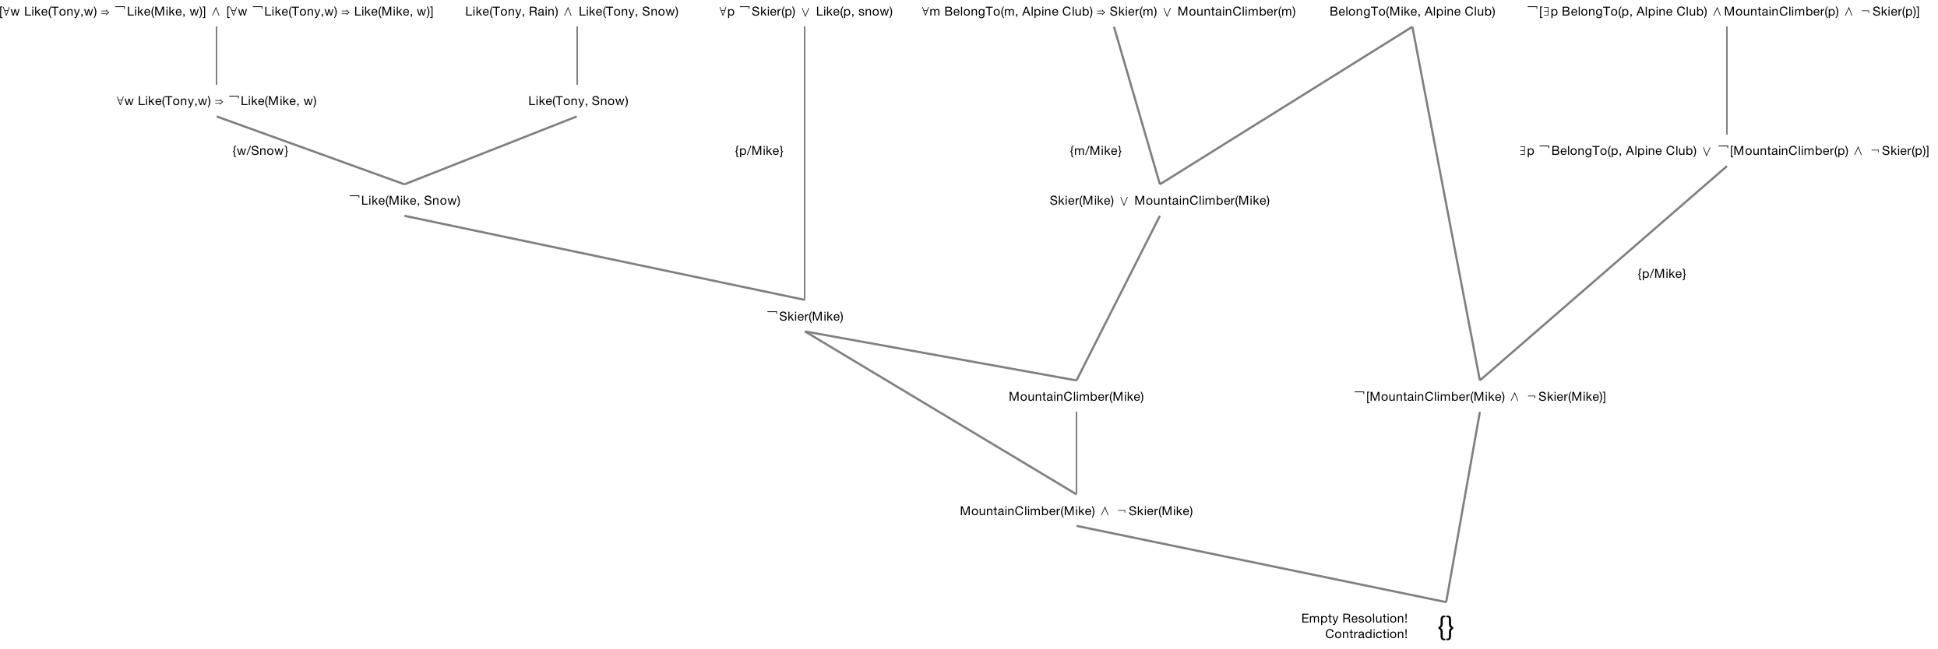According to the resolution refutation, we got the contradiction at KB ∧ ￢α, so the knowledge form the paragraph entails the statement.